SPH 321 Global Environmental Issues and Their Effect on Human Health
Spring 2021
Module 1
Homework Assignment 1
Objective: The objective of this homework assignment is to familiarize you with the concept of Planetary Health.
Part 1 of 3:
- Determine your ecological footprint using: https://www.footprintcalculator.org/
  - How many earths do we need if everybody lives like you?
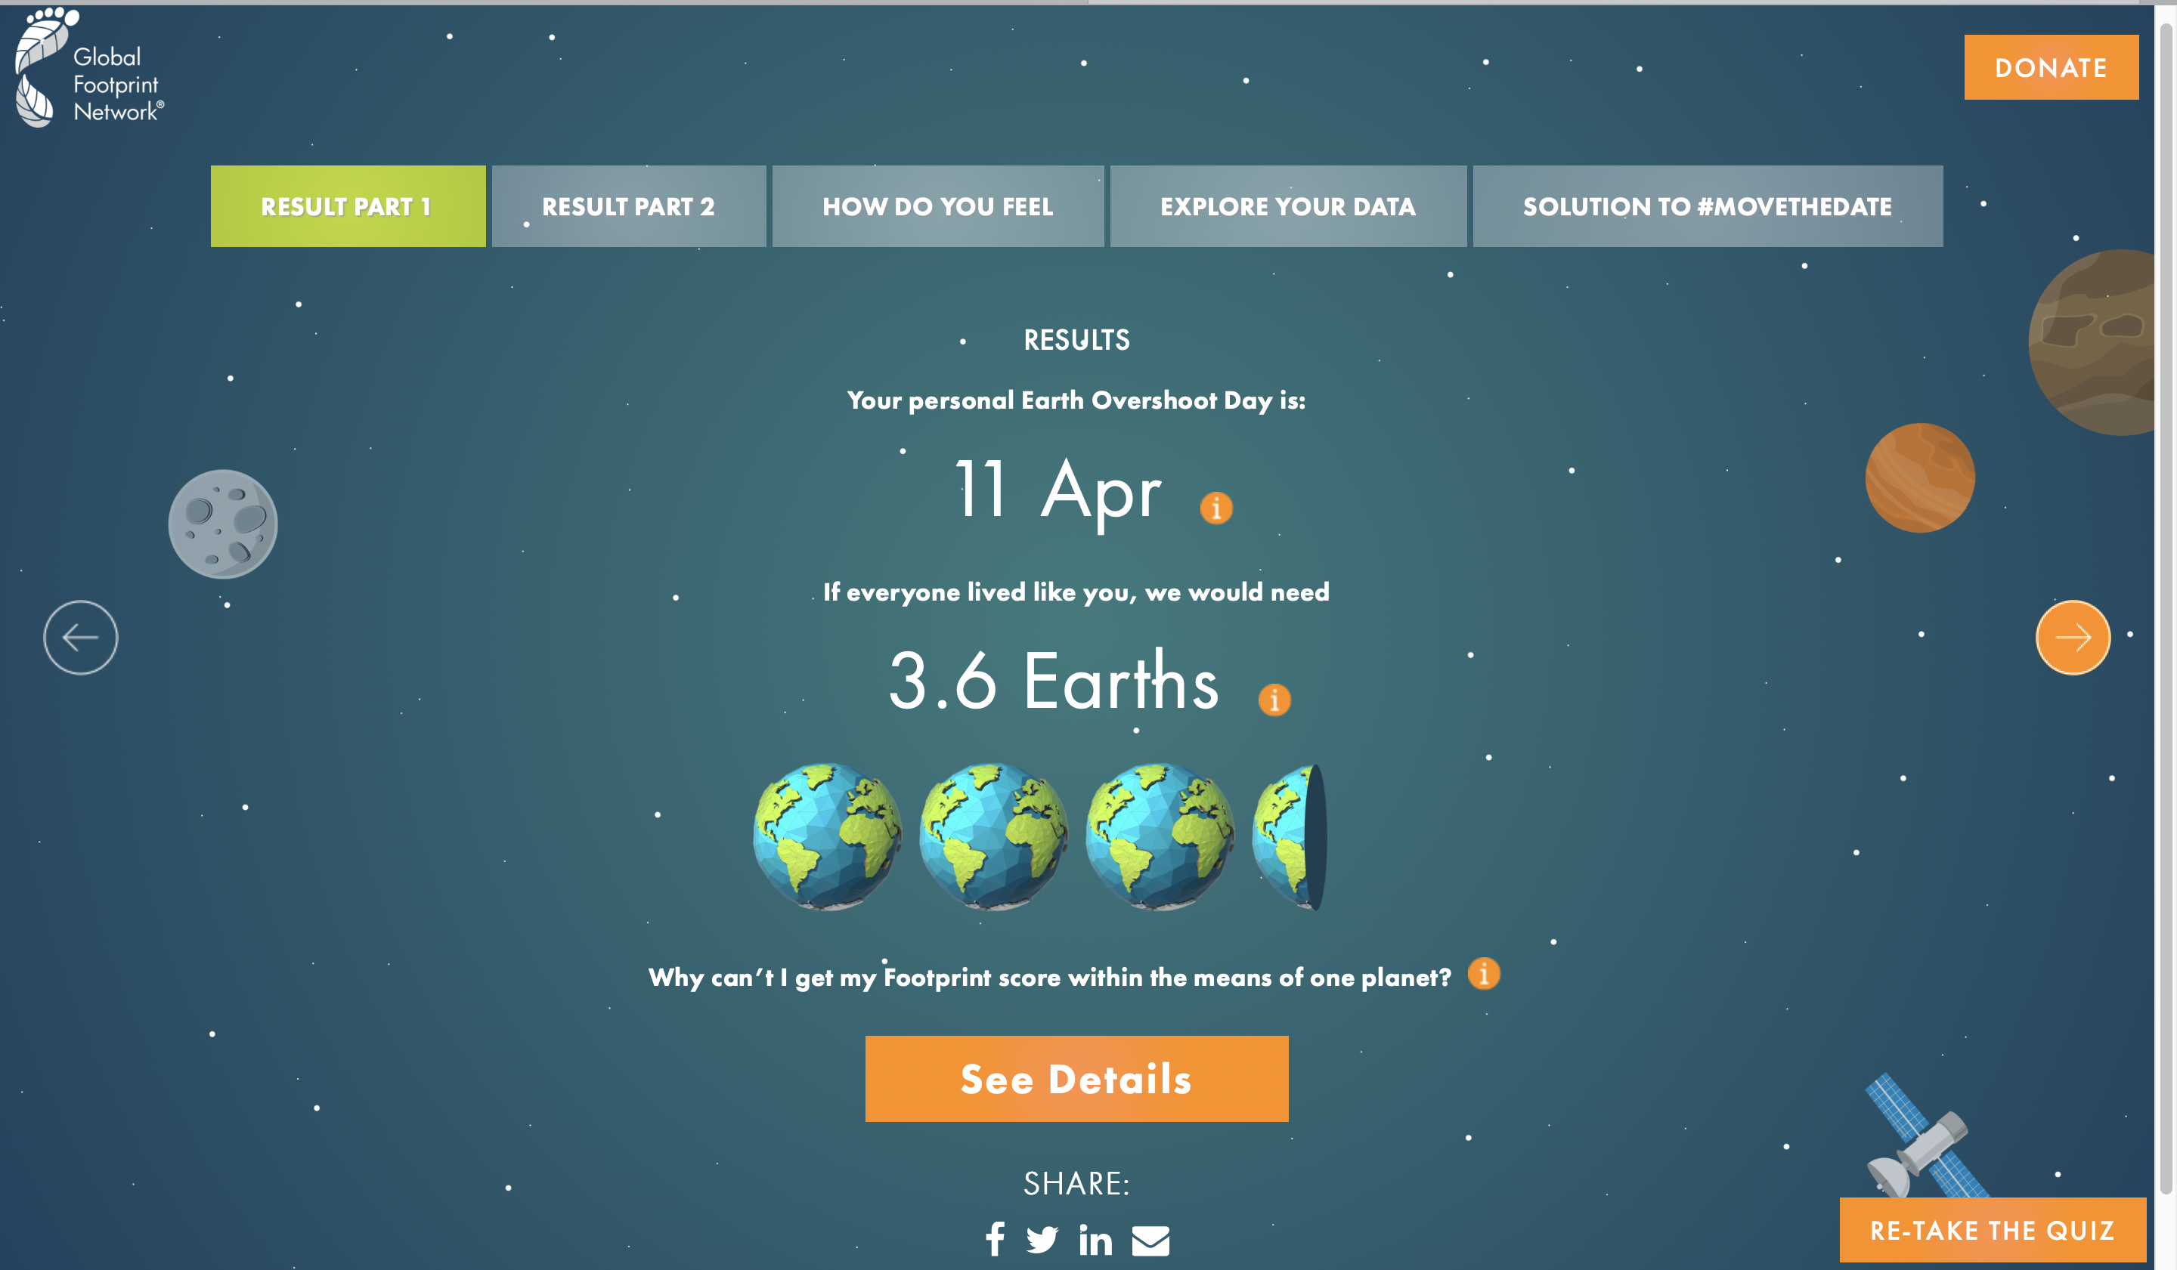

3.6 earths. See above picture.
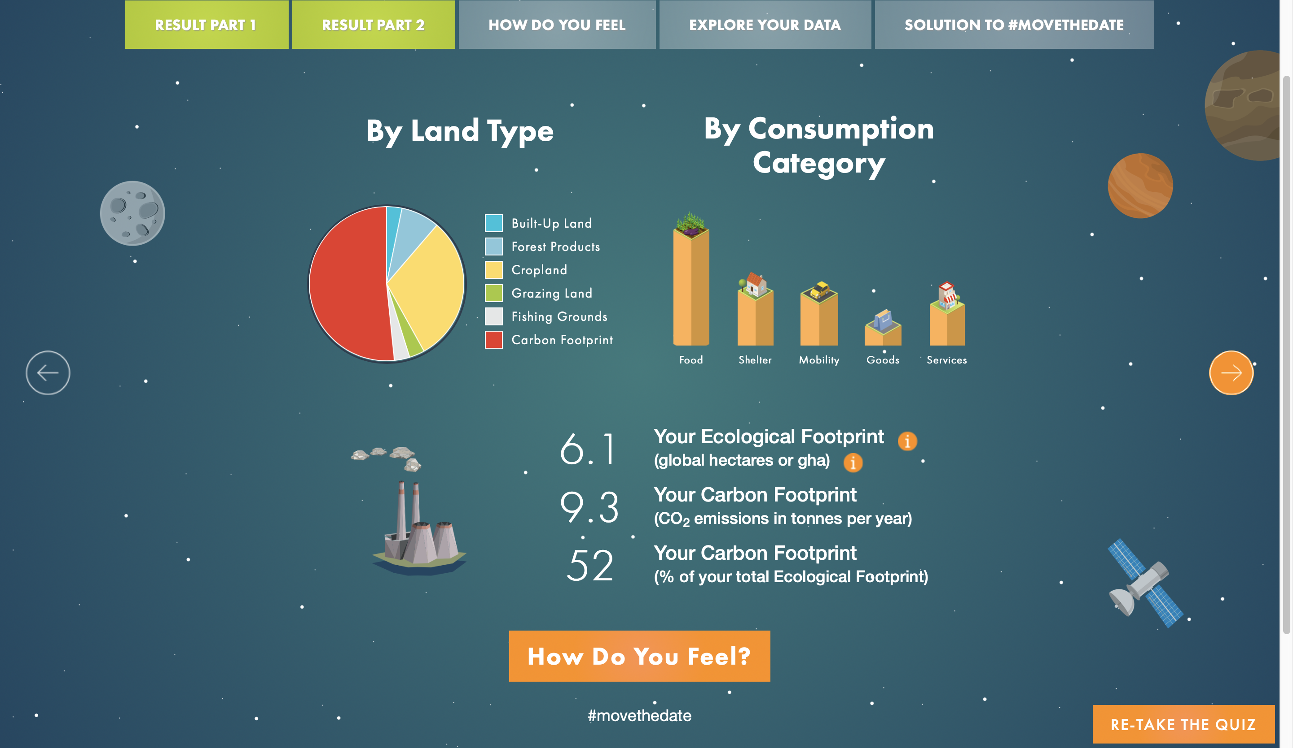
  - What is your ecological footprint (See Results part 2).

  - The USA ecological foot print per person is 8.1 gha. How do you match up in comparison?
My ecological footprint is higher than the average USA footprint per person.
  - Comment on the distribution of your footprint by consumption category (See Results Part 2).
Food leads in the footprint by consumption which is rational given the availability and access of food production versus consumption. It is followed by population which again can be explained by higher demand in housing due to increased population. Mobility and services follow and finally goods.
  - Now that you know your footprint, how do you feel? Try considering some of these questions or reflect on something else that struck you in this exercise.
    - Are there things that you can or want to change to lessen your footprint? Does it feel impossible to change some of these aspects? Why? How? Is changing some of these metrics seemingly out of your control?
The results of my ecological footprint have shocked me and it a wake up call for me. I always strive to live in a way that protect our environment for us and future generations. There are a lot of aspect that am going to change which are possible. For instance, am going adjust my eating habit as food toped my footprint distribution by consumption. Although some other aspect might be difficult to change at once, I will on the wrong run I have implemented the changes,
Part 2 of 3:
- Read the beginning of Safeguarding human health in the Anthropocene epoch: report of The Rockefeller Foundation–Lancet Commission on planetary health by Whitmee, et al. published in The Lancet. (posted on Blackboard and also available here: http://dx.doi.org/10.1016/S0140-6736(15)60901-1
  - Define the anthropocene in your own words based on what you’ve read here.
According to the article above, anthropocene is a term used to describe a geographical phenomenon or process where human activities start to have significant global effect on the earths system.
  - In your own words, describe why the authors contend that we need this new term?
Human beings are the primary determinants of the earths being and as a result, this new term need to be fronted and recognized to foster a health living that consider the earth current and future condition. Additionally, when the word is recognized, other concepts with are significant such as planetary health which is built on it can be used to address human challenges on earth and bring forward the best solution on how to protect and promote human health in the Anthropocene epoch
  - Define planetary health in your own words based on what you’ve read here.
This is the health of human being civilization and the state of natural system in which it depends on. It focuses on the balance between the sustainability of our civilization and the protection of our natural environment.
  - Consider one of the examples of the degradation of land resources from Chapter 4, or themes raised in Chapter 2 (urbanization, population growth, etc) that is of particular interest to you. Now that you have read a little bit about planetary health, reflect on the link between one of these themes and human health. 2 That is, consider in the context of your selected theme how humans are impacting the environment and the environment is in turn influencing health (or vice versa). Even though I assigned only the beginning of the Whitmee et al article, many of these themes are touched upon later in the manuscript. Scan the rest of the article to what the authors have to say on the topic and summarize it here. Please be sure to note the page numbers from the article where you gleaned information to answer this question. Your answer to this question should be no longer than 250 words.
Urbanization is the process of people moving from rural areas to urban areas in search for employment so as to lift their standards of life.as a result more industries are created in the urban areas to offer employment to those people. With increase in number of industries waste disposal has become a major challenge in the urban areas. Some of these industries release toxic gases to the atmosphere which cause global warming. As a result global warming leads to depletion of ozone layer which protect the earth from temperature rise and the sun from releasing harmful UV rays .as a result the harmful rays causes skin cancer and other harmful skin disease to people. Another effect of urbanization is increased disposal of plastic waste on the environment and other chemicals, this non-biodegradable waste pollutes hinders plants ability to thrive in such soils hence leading to low food production. This leads to insufficient food leading to malnutrition which affects the health of people.

Part 3 of 3:
- To connect Part 1 and Part 2 of this homework, consider how individual actions are related to planetary health.
  - Reflect on the footprint exercise now that you have read a bit about planetary health in a few sentences.
Human flourishment depends on the natural environment. However, it is the human being that are the forefront of destroying the natural system intentionally or unintentionally. Therefore, human activities need to be controlled for the current and the future planetary health. Although it is important to control such activities through rules and regulations, individual can make a difference also by changing their lifestyle behavior. There Is need for continuous education on the need to protect the environment to as it ensures public health is guaranteed and protected.
  - Offer an idea of a policy, a personal/household behavior change campaign, or some other sort of program, which - if implemented, could help individuals like yourself or your peers (or the larger population) both lessen your environmental footprint AND promote public health at the same time. For example, the Meatless Monday campaign aims to help people reduce weekly meat consumption (which is linked to a suite of cardiometabolic diseases) by encouraging vegetarian eating on Mondays. Your idea need not actually exist as a policy or program, you can be creative here but you need not go in depth – this is just a thought exercise. Be explicit about what environmental sustainability issue and what health issue you are addressing.
Plastic materials pose a great danger to our environment due to their inability to decay. However, we continue to use them on daily even on the situation where other best alternative exists. The best solution to handle this menace is for world organization such as world health organization influences countries to come up with laws and regulation that regulates production, distribution, and consumption of plastic materials. Additionally, government can help such subsidies and tax reliefs to companies that manufactures alternatives to plastics. One of the best campaigns to ensures this solution is achieved is the promotion of recycling the used plastics in areas where alternatives don’t exist. Instead of producing more, companies should buy back the used one and recycle them.

